**My city dream !**

I want, my city to be big and clean. So there were many modern centers, amusement park. I would like to have wide streets, a lot of cars, a lot of people and children, a lot of beautiful houses and museums.

So that there were many mountains, hills and many animals. There was a large forest, unusual plants grew. Tall trees. So that there were farms and farmers.

And so that people appreciate all this!

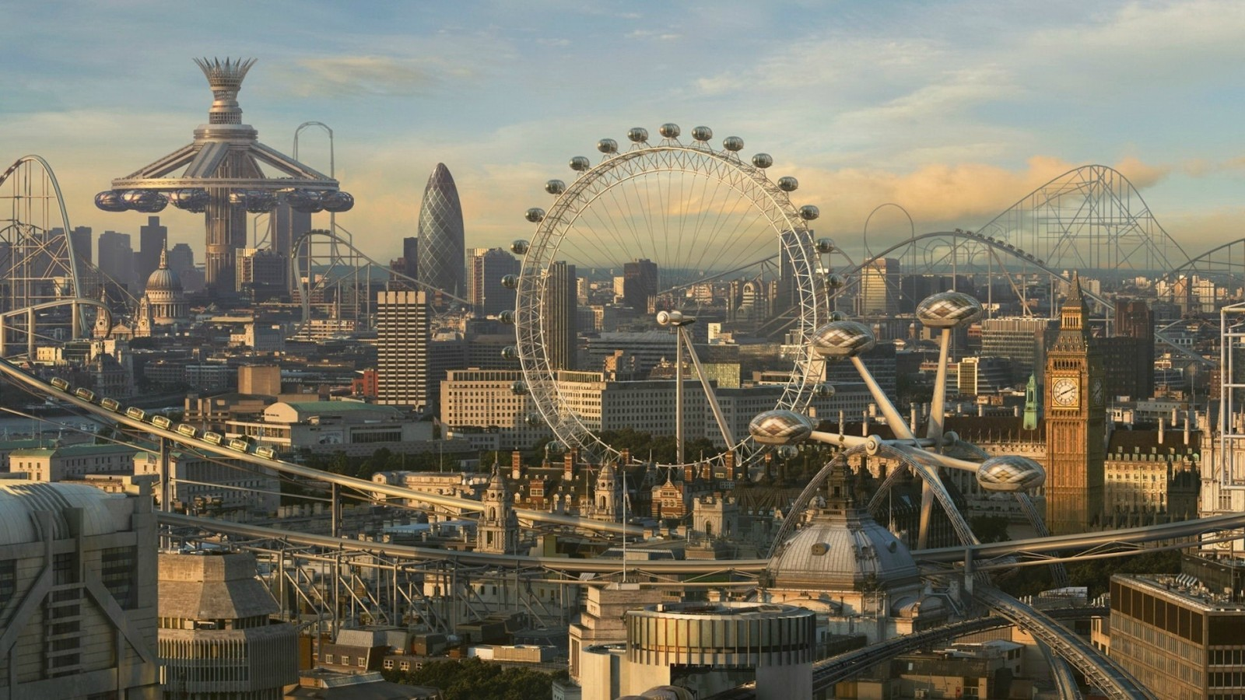

Ученица 5 «А» класса: Аскерова Амина

2020г