Project for English

« My favorites hobby »

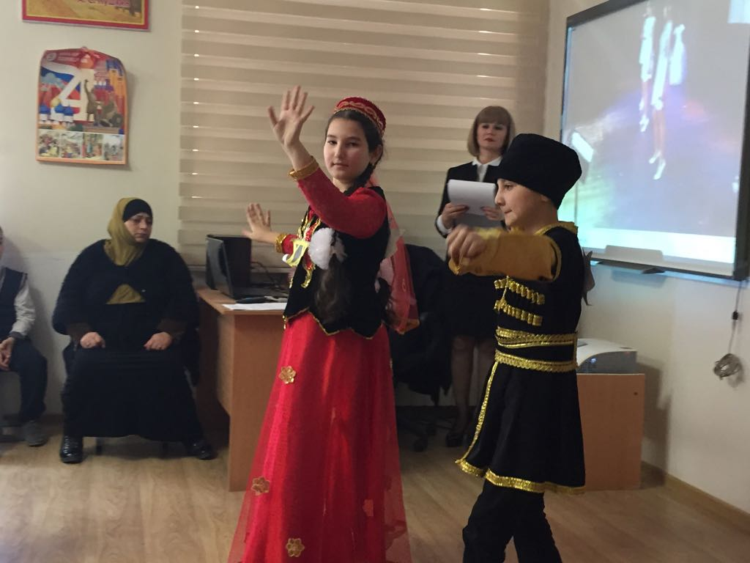

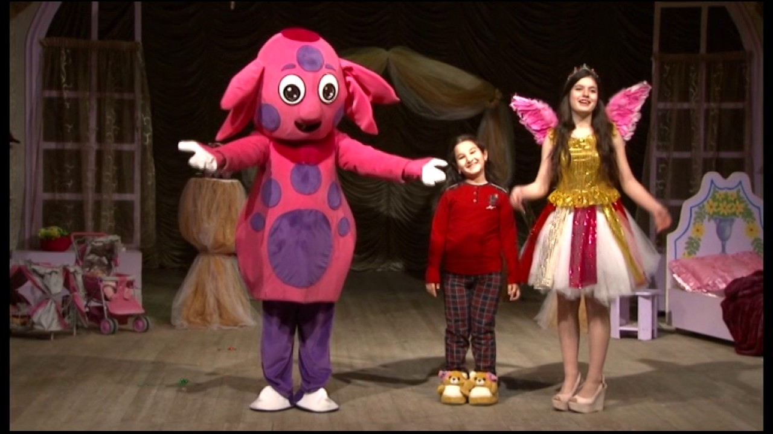

Выполнила уч-ся 5 «А»класса:

Аскерова Амина.

Руководитель: Аскерова Х.А.

2019год.

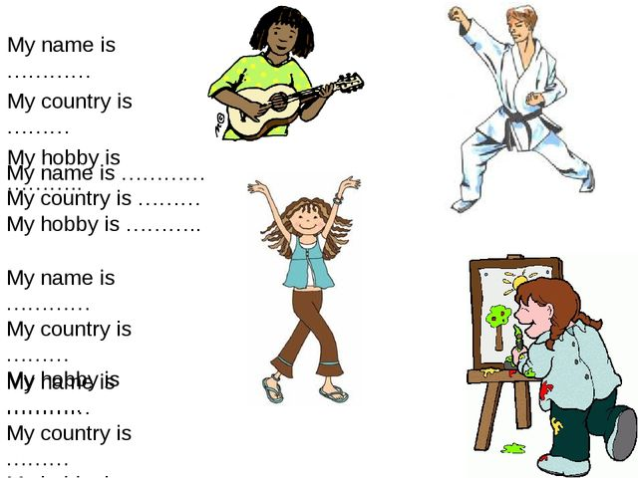

**Project for English**

**« My favorites hobby »**

**Every person has a hobby. I also have my favorite hobby. I love to sing, dance, play the piano and draw. Most of all I like to sing. I visit singing lesson. And I sing at various events. I can dance too. My brother and I, often perform at concerts and dance folk dance at school.**

